DELTA 2000, ANPI and the ENDAS club of Comacchio, under the patronage of Comune of Comacchio, of the Province Administration of Ferrara and of the Po Delta Park, in occasion of the 61st Anniversary of Comacchio Liberation
organise the
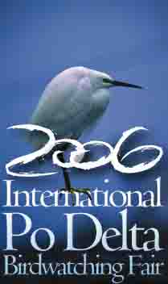
19th Cycling Tour of Liberty

Comacchio – Valli di Comacchio

Sunday April 30th 2006 8.30 am-6.30 pm

Programme
8.30 Meeting in the courtyard of Palazzo Bellini - Comacchio
9.45 departure from Palazzo Bellini courtyard (via Tre Ponti)
Route: via Spina – strada per Ostellato – Cavalcavia poderale Pallotta – Valle Pega – Argine Agosta
11.00 arrival in Valle Zavelea

Meeting with the 2nd Cycling tour in the heart of the Po Delta
(Alfonsine-Sant'Alberto-Comacchio)

Continuation along the route: Archeological site of Spina – Cippo Folegatti (stop)- and back to Comacchio.
Total route length Km 25.

PRIZE GIVING: Cups, trophies, Spina ceramics, prizes for the most numerous groups.
Food and beverage time with typical products such as with bun, tarts and various drinks.
At the end of the Ciclodelta prizes will be distributed to all the participants.
Ciclodelta association fee: €1

All the participants will be given a Bird card (valid from April 28 th 2006 to March 31 st 2007), a card of services allowing to all the activities of the Fair (excursions, environmental education laboratories, lectures, lessons of photography and birdwatching, theoretical and in the field, etc.) and to discounts and prices facilitations in shops and tourist facilities.

In event of consistent bad weather conditions, the cycling tour will take place on the following day, Monday May 1st, following the same programme.

Thanks to all the operators who contributed to the organisation, in particular to AVIS association, Comacchio.

